

October University for

Modern Sciences and Arts

Faculty of Computer Science

Graduation Project 1

CS405x

Spring 2019

(Educational Video Game Using Unreal Engine)

Under Supervision of Dr. Ahmed Farouk

Name: Amr Ahmed Hassan

ID: 161377

**Abstract**

In Egypt, the educational process has not changed for 22 years, but the new minister of education recently introduced a new system for education that will have more technology-oriented. We can use this further by introducing the use of video games in classes or as an extracurricular activity that the student engages in voluntarily. The use of many games has proved beneficial in many cases like Minecraft Education Edition and Assassin’s Creed Series. If those examples are used in making new games that give students or players immersive educational content in ways that could help them have better understanding of those topics.

Table of Contents

List of Figures 4

Chapter 1: Introduction 6

1.1 Project Overview: 7

1.2 Objective: 7

1.3 Motivation: 8

1.4 History: 8

1.5 Thesis: 9

Chapter 2: Background & Previous work 10

2.1 Background 11

2.1.1 Game Design, mechanics, and aesthetics 11

2.1.2 Education 13

2.1.3 STEM 15

2.1.4 Integration of video games in classrooms 16

2.2 Previous Work 17

2.2.1 Minecraft Education Edition 17

2.2.2 Assassin’s creed series 18

2.2.3 19

Chapter 3: Project planning & monitoring 20

3.1 Requirements 21

3.1.1 Functional Requirements 21

3.1.2 Non-Functional Requirements 21

3.2 Monitoring 21

References 22

# List of Figures

Figure 1 How game gives hints to player through light, game environment, and colors [3] 13

Figure 2 Tablet used by Egyptian students [1] 14

Figure 3 STEM Education four principles 15

Figure 4 Minecraft Education Edition Elements table 17

Figure 5 Notre-Dame Cathedral model from Assassin's Creed Unity [3] 18

List of Tables

Table 1 Comparison between formal and informal education [2] 14

# Chapter 1: Introduction

## 1.1 Project Overview:

Education in Egypt has been developed drastically in the past 2 years, the integration of handheld devices and online learning are changing the way students read and interact to learn new topics, and as students have hard time grasping and understanding science topics, the developed countries have multiple new approaches and methods of educating students, like using video games in classrooms, aside from their ages, no student likes sitting at a desk for hours being told what to think and how to think it while looking at a textbook. In theory this project will change how we educate student here in Egypt. By giving them a narrative and story to follow. They will learn about chemistry, physics and history in a compelling and engaging game. All while developing cognitive and cooperative skills. Since video games has a huge share of almost every student’s day, we can use that time to help develop skills and educate them rather than let them waste it. The old system we have now does not help students in a practical way. Therefore, our game will show them scientific experiments that will make them to do research and other activities that require usage of cognitive skills, which in part will stimulate their eager to learn more and engage in the scientific field and learn about many interesting topics.

## 1.2 Objective:

To help students who have problems with the current educational methods or homeschoolers or even disabled students, that can’t move or go to school for any reason. Also deliver educational content in a more interesting ways so that the students will focus more and be eager to uncover the mysteries of the game. With cognitive and cooperative skills, they will be able to understand the concept of the game and advance through the story and will be eager to learn more and explore our virtual world.

## 1.3 Motivation:

Video games addiction recently became an official mental health disorder and recognized by health organizations such as WHO and they released an official manual for diagnosing this illness. In order to have more control over this phenomenon we need to provide a less addictive and productive games that will help the students have better understanding of the world and will help them understand the value of their time. The proposed game was fantasized by me as a child and was stuck on my mind till this day. So, this is my dream come true in a way, help people and have fun at the same time. Students waste a lot of their time playing video games that might also affect their school work badly and their lives if they were addicted to those games. Therefore, if you provide and alternative solution that will help them in their school work and be fun at the same time, it will be a much better option.

## 1.4 History:

Educational video games have been done before in many ways and the most successful ones were when games like current popular games were made, for example games like Fortnite, Pacman and other addictive games. Although that most video game players are above 18. Most games that you can find online are a bit childish and silly. So, the target audience for those games were ranging from 4-10 years old, while educational games for adults or teens are nonexistent. The education system itself In Egypt has been at a stalemate for a long time now and it needs development and restructuring to help students face the new challenges of life that comes with progress and new technologies that arise. The world is changing so fast that educational systems are lagging in so many ways. Computer classes in Egypt are outdated and not informative. History classes have you remembering names and events rather than knowing the impact of it. Historical events are taught through books and images rather than going to the monuments in which those events took place. Great historic figures are being described in the least informative ways. In the game those events will have much more impact on the students since they are interacting with it, and in some way living through it. The graphics and visuals will help the students retain the information that is being given to them.

## 1.5 Thesis:

In Chapter one we will discuss the idea and how to help students with video games. Chapter two we will give an idea about similar educational games and game design concepts. Chapter 3 will be about the non-functional and functional requirements which will be needed for the project and analysis.

# Chapter 2: Background & Previous work

## 2.1 Background

### 2.1.1 Game Design, mechanics, and aesthetics

Game design is a process in which the game designers look for the “fun” parts in a game and how to make the player like the game and interact with the game world, there are many ways to do that, By making the game extremely hard, like Dark Souls or Sekiro Shadows Die Twice, or by making the game feels like a movie and have emotional impact, like Beyond two souls and Heavy Rain. But what is common between all games is that they are all some sort of escape from reality. Players have the impressions of living different lives and engaging in exciting new worlds. The sense of accomplishment that games give them make them get attached to it if their real life is boring or empty at the time. Moreover, if they are stressed video games can help reduce that stress.

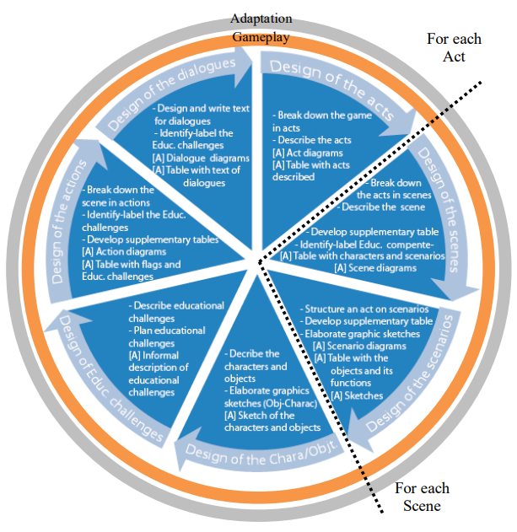

Figure Educational Game design process layout [10]

Game mechanics are the core of the game. What the player can do, how to interact with the world, and what they can’t do. Game mechanics set the goal of the game and a description of how to reach that goal. Aesthetics of the game must support those mechanics in affordance and clearly laying out the goal. Tutorials and orientation must be provided to the player or if the game is intuitive then the pace must be slow. Then the pace changes as the player progress through the game, and new mechanics can be introduced when the player masters the ones used. In our game the player will be introduced to the open world in a cinematic way that will slowly introduce him/her to how the game is played and what is the goal of the protagonist. The player will have the choice to explore the world or doo missions or side missions all while uncovering the secrets of the world and discovering new mechanics. Also, the educational content will be shown to the player and he/she will interact in some activities in the game that will help them further understand those topics.

One of the aspects of game design is the aesthetics. The aesthetics of any game is set by the game world design and the dynamics of the game. How the game feels and how it looks must take time out of the development cycle and considered equally important as other aspects of the game. Using lights, colors, or the player’s camera to guide the player to important parts or to focus on what we want him to see is used in a lot of successful games. For example, in Uncharted the player is guided through out the game by the camera, lights, colors, and structures to focus at what the game wants him/her to [3]. Some games’ ideas are built around that concept. Some use color contrast and give important parts of the environment different color so that the player will notice them and progress through the game level. Light spots also give the player a clue where to look or what to look at. In some cases, the camera is moved so that the player would notice what the designer wants to show. But the difference between a good game and a bad one is how that technique is implemented.

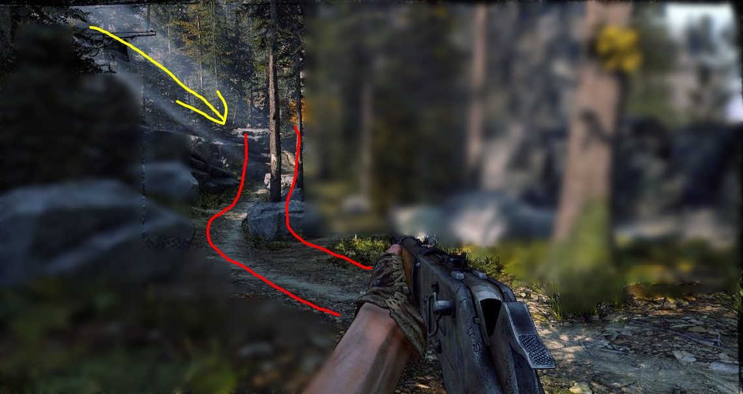

Figure How game gives hints to player through light, game environment, and colors [7]

Informal education is a way to encourage students to have more passion for learning and provide interesting topics for them to research about and stimulate their minds and thoughts

### 2.1.2 Education

The new minister of education has made a huge plan for the reform of education in Egypt. After 22 years of using the same system at public schools the new minister is set to change the curricula, examinations’ format, and the methods of educating students. This new system will render private tutors useless and give more room for students to research and learn by themselves in whichever topic they choose. Also, the introduction of the use of handheld devices [1] to students and teachers alike, will be more time-efficient for teachers to grade tests, students will be capable of doing more research, watch educational videos, also they will do online exams which will eliminate the need for papers and pens. Both sides will be better equipped to use modern technology and online applications. If we further this plan a bit more and introduce educational video games to students and in classes, it will help students have better use of their time in understanding content the already study or explore new topics they could further research.



Figure 3 Tablet used by Egyptian students [2]

Educational video games effect on classrooms has many factors. They educators and students set the environment which video games can enrich or have no effect based on the involved parties and their willingness to learn or educate. But the effect games have on students critical thinking, creativity and cooperation is noticeable.

Table 1 Comparison between formal and informal education [2]

|  |  |  |
| --- | --- | --- |
|  | Informal Contexts | Formal Contexts |
| Time Structure | Flexible | Rigid |
| Participation | Voluntary | Compulsory |
| |  |  | | --- | --- | | Educational Goals |  | | Emergent | Largely defined |
| Age Grouping | Flexible | Largely age divided |
| Degree of Authenticity | Potentially high | Generally low |
| Uniformity of Outcomes | Little | High |
| |  |  | | --- | --- | | Disciplinary Boundaries |  | | Flexible | Fixed |

### 2.1.3 STEM

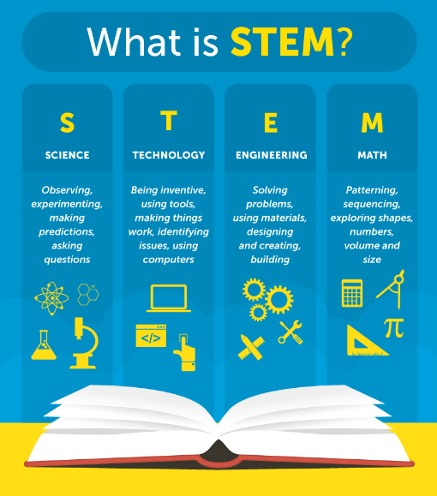

Figure 4 STEM Education four principles [4]

STEM Education system is based on four disciplines: Science, Technology, Engineering and Mathematics. This educational system uses the four topics as interrelated topics rather than teaching each of them as a separate subject, while integrating them to real-life applications and practical experiments. With the increasing demand for computing related jobs i.e. data science and information technology, the education must take a step to provide a suitable workforce for the rapidly changing work field. Our game will try to achieve that in a cinematic, immersive, and engaging way. We will help players have better understanding of some chosen scientific topics. They will be introduced to basic programming ideas and some small challenges that will require them to do some research about scientific topics and some engineering concepts will be demonstrated in the game. And if we look at the figure above (Figure 3) we will find out that most of those activities are already done in games but in different context. Therefore, if we could integrate those activities in a context where the player learns about science, mathematics, technology, and engineering it will prove beneficial to the students or players.

### 2.1.4 Integration of video games in classrooms

Video games are looked at by some parents and educators as a pejorative means of teaching students. But in fact, the use of video games in classrooms increases the “fun” and makes students eager to learn more, the way educators integrate video games is unsuccessful due to many reasons which involves the preconceived worries and misconceptions about gaming. Productive use of this form of education depends on educators and training provided for them to enable them to better utilize video games as a part of their day-to-day routine in class. But for the time being the best solution is to make educational games a way of informal education that the student or player engage in voluntarily.

## 2.2 Previous Work

### 2.2.1 Minecraft Education Edition

This game is exclusively available to schools that subscribe to it, individuals can’t buy this game or play it. In this game whole classrooms are introduced to the world of Minecraft, where they can learn, build, craft, and discover together, without the need for a separate server. Educators can create NPCs to guide, direct, or provide information to the players, also the game allows them to insert active web links if the players would like to explore additional resources. Players are introduced to classes and education in much more appealing ways. They learn about chemistry in interactive way. The learn about geometry and architecture by building structures in the game. They can do all of this alone or with friends from their classes. Educators can monitor and control student’s activity through chat and level adjustments. The many elements of the game make it harder for students to explore alone, that’s why the presence of teachers in this case in crucial to the educational aspect to be understandable and comprehensible.

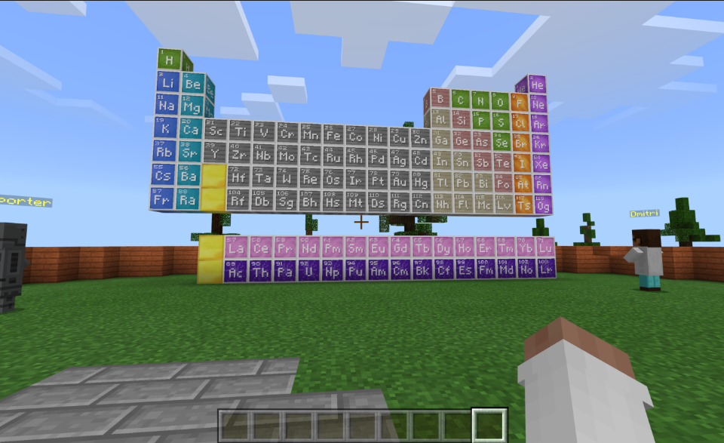

Figure Minecraft Education Edition Elements table [13]

### 2.2.2 Assassin’s creed series

Even though this game is not educational in nature. But the value of seeing and interacting with historic characters and events give the player the sense of living though those lives and exploring ancient cities and meeting people they only read about in books. The way this game tackles history and presents it to the player makes it feel like reality and players have much more “fun” going through history class that way. We can use this game as a guide when it comes to immersion and storytelling. The series explored ancient Egypt and Alexandria and made a sperate version from the original game to students and history enthusiasts so that that they could walk through ancient Egypt roads and learn about the culture, geometry, and architecture of this great civilization. This feature is called Discovery and it provides 75 tours guided by historians and Egyptologists with durations ranging from 5 to 25 minutes. But you can break away from the group at any time and explore on your own.

Also models from Assassin’s Creed Unity was used in the recent events in Paris to reconstruct the famous Notre-Dame cathedral. Those models took a lot of time from the developers to make and accurately old French cities and it came in handy when the original building caught on fire while being renovated.

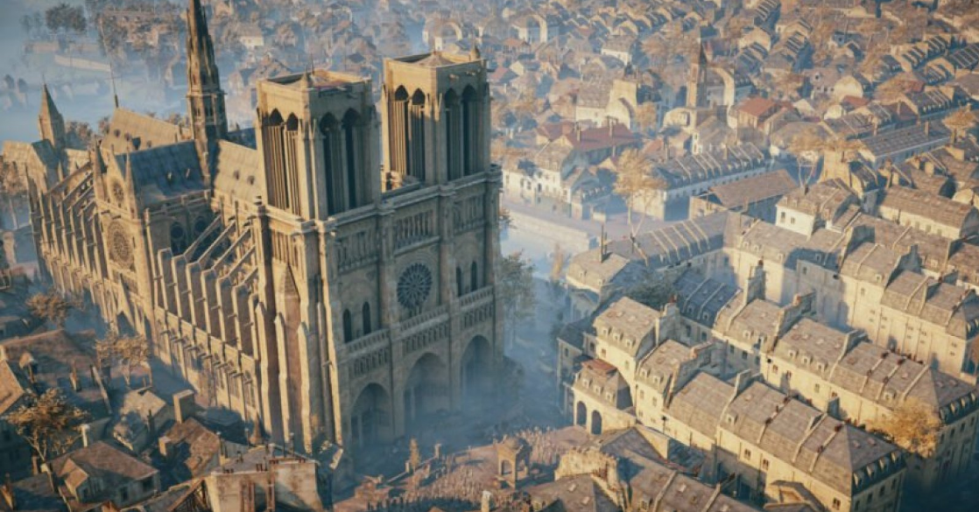

Figure Notre-Dame Cathedral model from Assassin's Creed Unity [5]

# Chapter 3: Project planning & monitoring

## 3.1 Requirements

We will use unreal engine and assets from epic games store and specially made assets to make our proposed game.

### 3.1.1 Functional Requirements

* The game shall allow a player to start new game or load a game.
* The game shall allow a player to exit the game.
* The game shall allow a user to be a player.
* The game shall allow sounds and sound effects.
* The game shall allow interaction between the player and actors in the world.
* The game shall provide the player with set of rules at the start of the game.
* The game shall allow the player to navigate the game world.
* The map shall allow the presence of buildings.
* The map shall allow the presence of hills.
* The map shall allow the presence of plains.

### 3.1.2 Non-Functional Requirements

* The minimum frame rate must be at least 30 and average greater than 30.
* The response time of each action in game must be less than 0.5 seconds
* The system must run compatible operating system
* Latest graphic driver installed
* Latest DirectX

## 3.2 Monitoring

* 2-months game design and planning
* 3-months game development and optimization
* 2 weeks testing the game and evaluation

# References

1. Annetta, L. (2008). Video Games in Education: Why They Should Be Used and How They Are Being Used. Theory into Practice, 47(3), 229-239. Retrieved from http://www.jstor.org/stable/40071547
2. Business/Economy. (2012, April 28). Retrieved from AhramOnline: http://english.ahram.org.eg/NewsContent/3/12/40362/Business/Economy/Egypt-authorities-to-supply-,-tablet-PCs-to-studen.aspx
3. Council, N. R. (2011). Learning Science Through Computer Games and Simulations. Washington, DC: The National Academies Press.
4. FLANNIGAN, C. (2017, May 15). Kids in STEM: Science, Technology, Engineering, and Math. Retrieved June 8, 2019, from https://www.fix.com/blog/getting-kids-involved-in-stem/
5. Holt, K. (2019, 04 17). Ubisoft is donating $564,000 to help rebuild Notre-Dame. Retrieved from Endgadget: https://www.engadget.com/2019/04/17/notre-dame-fire-apple-ubisoft-assassins-creed-unity/
6. Lankoski, Petri & Björk, Staffan. (2008). Character-Driven Game Design: Characters, Conflict, and Gameplay.
7. MELENDEZ, C. (n.d.). PUSH & PULL. Retrieved from CLÉMENT MELENDEZ - Level Designer: http://www.clement-melendez.com/portfolio/articles/push-pull/affordance/
8. R. P. De Lope, N. Medina-Medina, R. M. Soldado, A. M. García and F. L. Gutiérrez-Vela, "Designing educational games: Key elements and methodological approach," 2017 9th International Conference on Virtual Worlds and Games for Serious Applications (VS-Games), Athens, 2017, pp. 63-70.
9. doi: 10.1109/VS-GAMES.2017.8055812
10. Rafael P. De Lope, N. M.-M.-V. (2017, September). Designing educational games: key elements and. IEEE, 63-70.
11. RobeRt Kenny, G. G. (2011). Factors Affecting Adoption of Video Games in the Classroom. Journal of Interactive Learning Research , 259-276.
12. Ruggiero, D. (n.d.). Video Games in the Classroom: The Teacher Point of View. Bath, United Kingdom: Bath Spa University .
13. Wilson, L. (2018, June 14). Microsoft | Developer. Retrieved from Minecraft Education Edition: World of Chemistry: https://blogs.msdn.microsoft.com/teachers/?p=17055
14. Winn, B. M. (2009). The Design, Play, and Experience Framework. In B. M. Winn, Handbook of Research on Effective Electronic Gaming in Education (pp. 1010-1024). Michigan State, USA: Michigan State University.